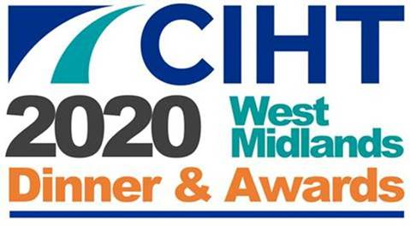

Best Small Project Award 2020

Individual projects (less than £5 million) that are outstanding examples of transportation or highway projects, demonstrating they have been delivered on time, to budget and made a major contribution to the West Midlands.

Entries must clearly explain how the submission meets the criteria specified.

Maximum marks attainable for each criteria noted in brackets.

**Judging Criteria for the award:**

* Benefits to the community (15)
* Benefits to the environment (15)
* Implementation and delivery of project (15)
* Engagement and communication with Stakeholders (10)
* Planning and Design (10)
* Enterprise, innovation and ingenuity (10)
* Objectives met including time, cost & quality (10)
* Value for money with benefits versus costs (10)
* Wider implementation potential (5)

**How to enter:**

To enter this award please complete an Entry Form and provide a 1,000 word maximum supporting document on your entered project, and return to:

<https://www.ciht.org.uk/about-us/uk-nations-regions/west-midlands/west-midlands-awards-2020/>

**The deadline for entries is 23:59 on Wednesday 1 April 2020.**

Judging will commence from 2 April 2020 and shortlisted entries will be notified in early April.

Winners of the CIHT West Midlands Awards 2020 will be announced at the CIHT West Midlands Awards Dinner on the evening of Thursday 7 May 2020 and details published through a variety of media platforms.