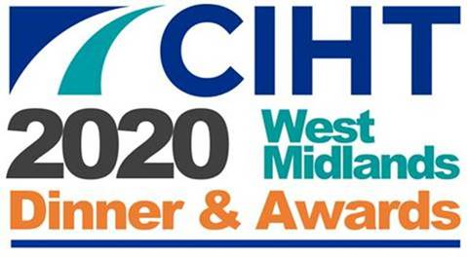

Environment and Sustainability Award 2020

Examples of excellence in environment and sustainability in the highways and transportation industry in the West Midlands.

Entries must clearly explain how the submission meets the criteria specified.

Maximum marks attainable for each criteria are noted in brackets.

**Judging Criteria for the award:**

* Evidence of Environment and Sustainability as a key driver (30)
* Design of solution including efficiency and sustainability (30)
* Performance measures, user feedback & benefit to the user (10)
* Implementation of solution including communications (10)
* Value for money including outcomes and benefits versus cost (10)
* Wider implementation potential (10)

**How to enter:**

To enter this award please complete an Entry Form and provide a 1,000 word maximum supporting document on your entered project, and return to:

<https://www.ciht.org.uk/about-us/uk-nations-regions/west-midlands/west-midlands-awards-2020/>

Please ensure that you have read the Submission Information before submitting your entry.

**The deadline for entries is 23:59 on Wednesday 1 April 2020**

Judging will commence on 2 April and shortlisted entries will be notified in early April. Winners of the CIHT West Midlands Innovation Award 2020 will be announced at the CIHT West Midlands Awards Dinner on the evening of Thursday 7 May 2020 and details published through a variety of media platforms.