MyCareerPath User Guide
CPD Activity

Contents

How Does MyCareerPath Work 2
Creating a MyCareerPath account 2
Adding a quick CPD Record 5
Evidence Wizard - Adding Detailed CPD Records 6
Sending Your Evidence for Review 7
Uploading Supporting Documents 7
Creating a Professional Development Action Plan in MyCareerPath 8
Generating a Report in MyCareerPath 9
Forgotten your MyCareerPath Password? 11
Editing your MyCareerPath details 12
For More Information 13

How Does MyCareerPath Work
MyCareerPath works by enabling CIHT Members to record their CPD activities quickly and easily so they can build up an online portfolio that supports their professional development.

MyCareerPath also allows Members to share evidence of their activities with a Mentor for feedback, or to CIHT if they are called upon to submit a CPD record during CIHT’s annual CPD review process.

Creating a MyCareerPath account
To create a CIHT MyCareerPath account, please follow this link, which can also be accessed from the CIHT’s members area, or through CIHT’s new Professional Development Framework.

The link will take members to the MyCareerPath login page where they may either login to an existing account straight away or register a new account.

Please see the screenshot below that highlights a member can either login or register on the same page.

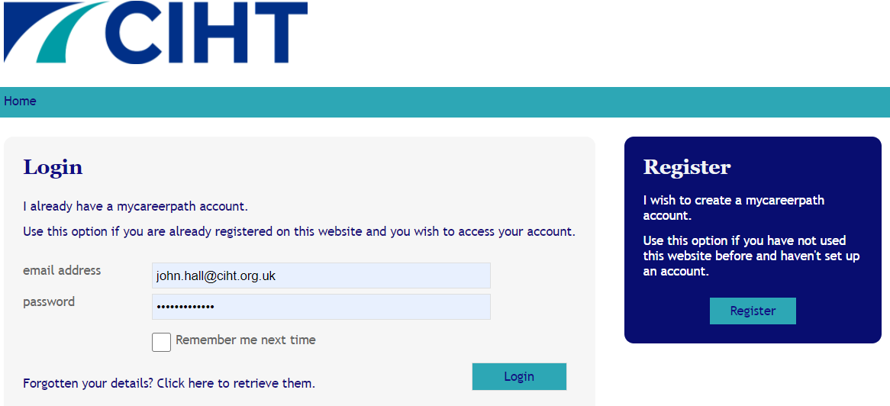

Please see below screenshot of what a member will see when registering their own MyCareerPath account.

Please following the on-screen guidance and remember that all fields marked with an asterisk * are mandatory.

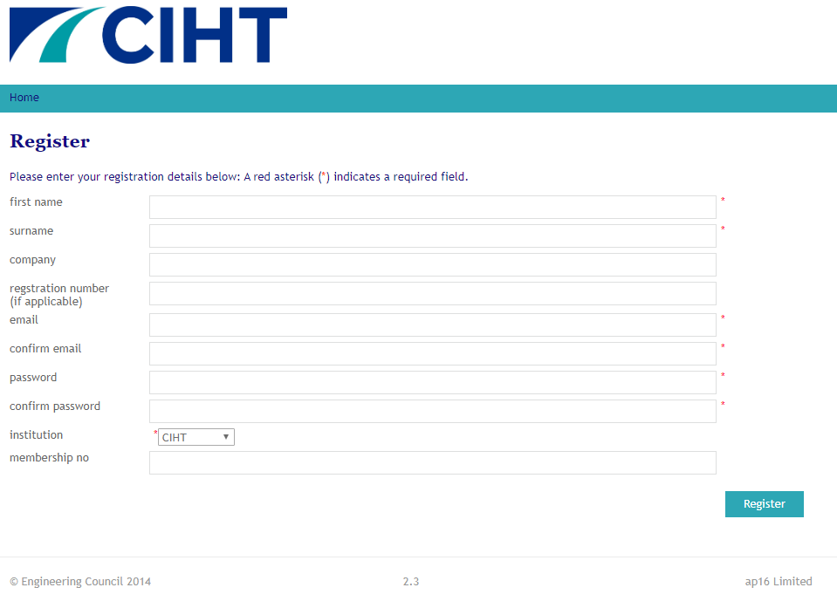

Once a member has registered and logged on, they will see the below page. From here, they can access every service on the MyCareerPath online platform.

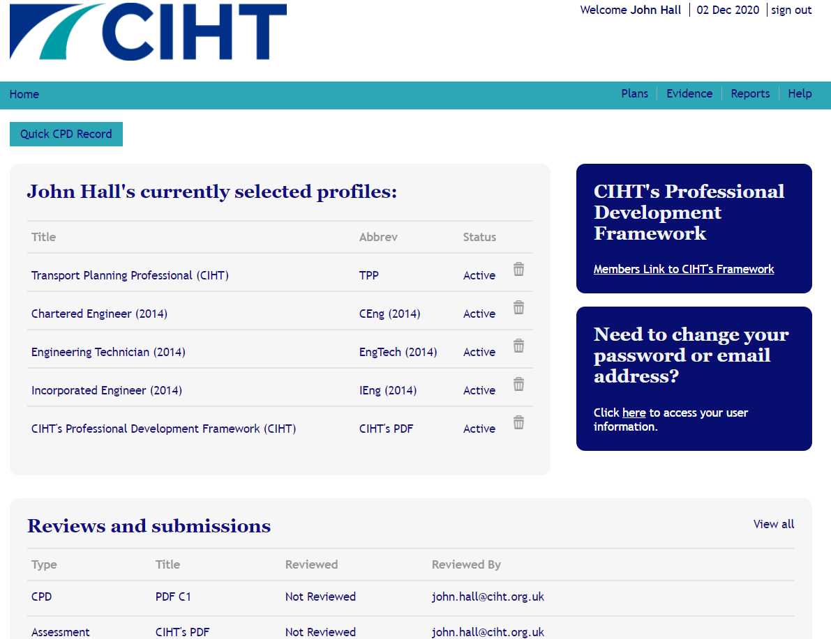

Adding a quick CPD Record

Now a member has registered a MyCareerPath account and logged in, they can begin to record their CPD activities. Any record they enter will be added to a portfolio of evidence on MyCareerPath.

Whether they are on the move, on site or do not have a lot of time to record your CPD, MyCareerPath allows members to add a quick CPD record on the home page, or create more detailed CPD records with the Evidence Wizard, which will be covered in more detail on the next page.

To add a quick CPD record, simply click the quick CPD record circled below, enter a title for the activity, some details, and a date. Please see below a screenshot of what will be seen when submitting a quick CPD record.

Members can later generate all their archived activities into a report that can be saved or shared with a mentor for feedback.

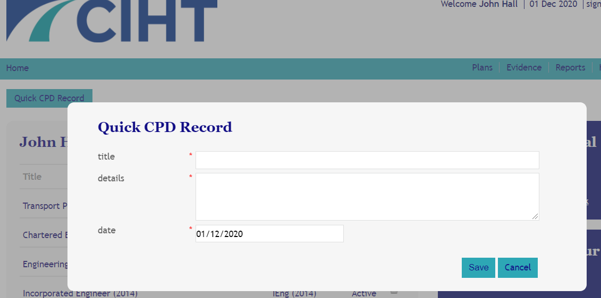

Evidence Wizard - Adding Detailed CPD Records

The Evidence Wizard can be used when memb ers have more time to spare when recording the CPD activity they have undertaken. The Evidence Wizard provides an opportunity to detail any lessons learned, and benefits gained from the activity.

Exactly like the quick CPD record function, any activity added using the Evidence Wizard will be added to a portfolio of evidence on the platform.

All gathered evidence can later be generated into a report that can be saved or shared with a mentor for feedback.

Please see below a screenshot of an example of a more detailed CPD record via the Evidence Wizard.

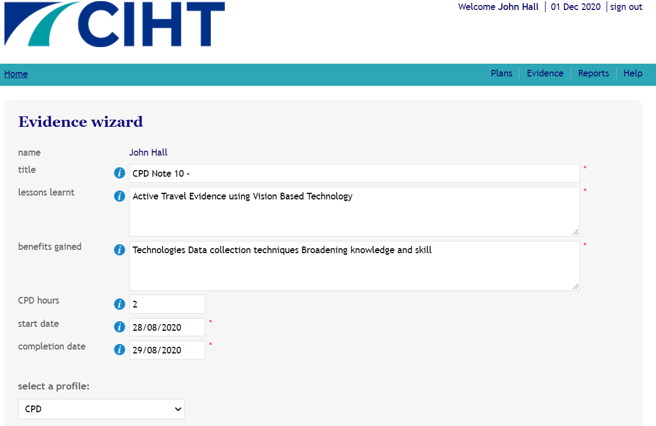

Sending Your Evidence for Review

On the Evidence Wizard page, members may share their CPD portfolio with anyone who has a MyCareerPath account. Simply enter the email address of the person to receive the evidence & click save and review. The recipient will receive an email inviting him or her to view the page and add comments.

Please see below a screenshot of what you will see when sending your evidence for review..

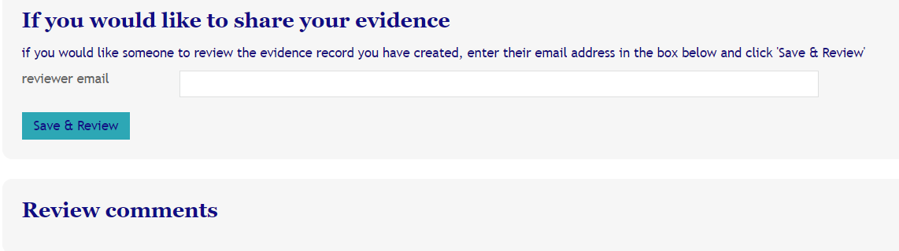

Uploading Supporting Documents

If summarizing CPD activity is difficult, supporting documents can now also be Uploaded to MyCareerPath in the form of (Word, Excel, PowerPoint, PDF, image, and media files). Through MyCareerPath, these supporting documents can be sent directly to a mentor for review and comment, or straight to a CPD Reviewer.

Please see below a screenshot of what will be seen when uploading supporting documents.

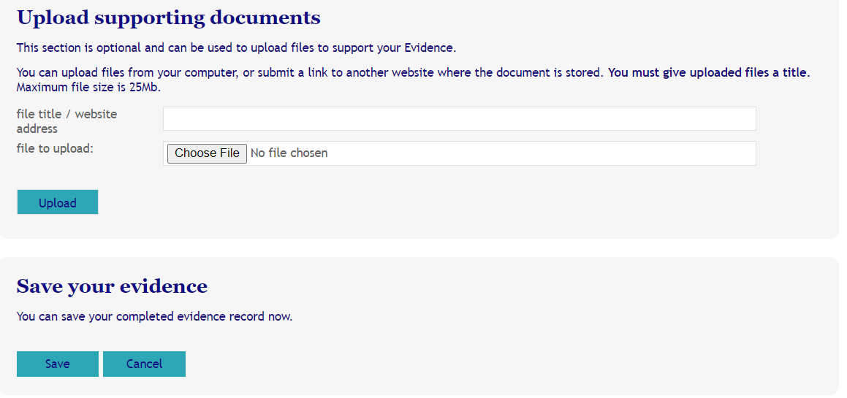

Remember to Save when finished.

Creating a Professional Development Action Plan in MyCareerPath

Why is an action plan needed?
Creating a Professional Development Action Plan (PDAP) is a critical part of maintaining a members professional standards. It will allow them to reflect on the work they have already done and develop (with their Mentor) a plan for the next year. This ensures they remain on course and continue to demonstrate commitment to their own progression and that of the sector.

Guide to creating a PDAP in MyCareerPath

Select Plans in the banner menu, then select the Add Plan button

Enter some details about the action plan, then from the drop-down menu, select the appropriate profile that to record Professional development against (e.g. CPD).

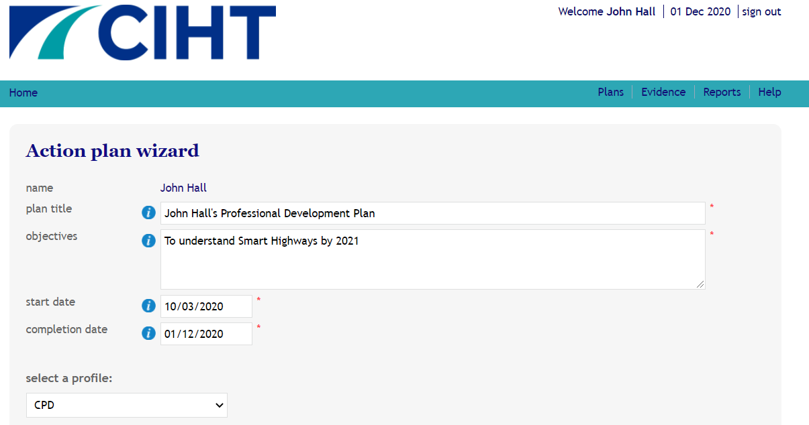

The members new Plan will then appear in the Plans section in the banner menu

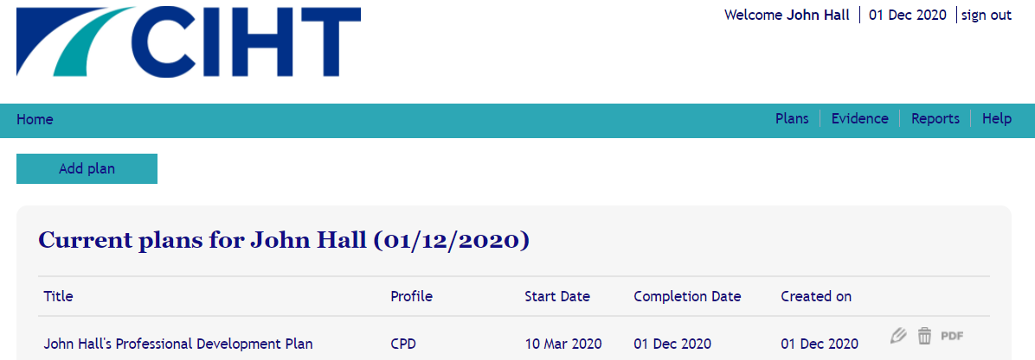

Generating a Report in MyCareerPath

Reports are used to gather plans and evidence over a specified period. Using MyCareerPath members can generate a CPD based report which shows all the activity they have submitted. The report can be tailored to capture specific periods in time.

There are 2 types of reports in MyCareerPath. The first is the Quick CPD Report. Clicking the Quick CPD Report will bring up the CPD activity undertaken in a simple format that can quickly and easily shared with a Mentor or Reviewer.

The second type of report is more detailed and bespoke. Select Reports in the menu; then Add Report

On the resulting Report Wizard page, members can give their new report a Title; enter Start and End dates for the period the report covers and then select the Profile to report on (e.g. CPD).

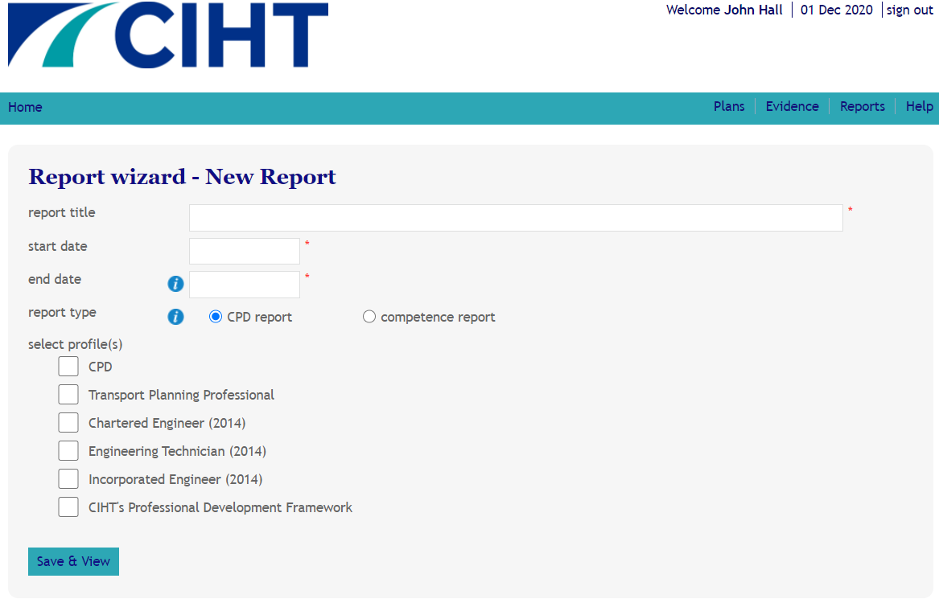

Remember to Save reports before they can viewed or send for review.

Forgotten your MyCareerPath Password?

Forgotten our password, no problem. Please use the Forgotten Your Details? link on the bottom of the login page.

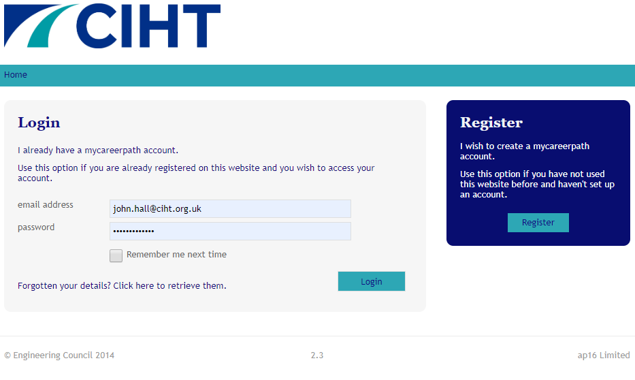

You will then be prompted to enter the email address used to register

Select Send Email a password reset link will be sent to that address.

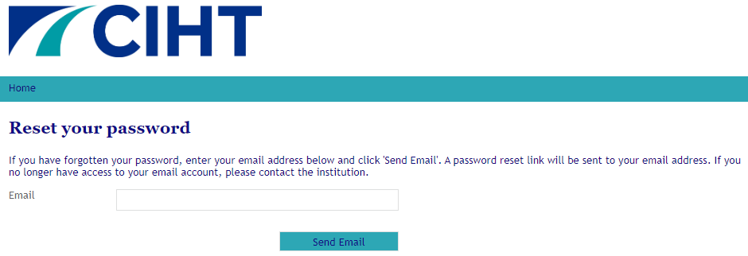

Editing your MyCareerPath details

Once registered, members may change their details at any time on MyCareerPath.

To do so, please return to the Home page and follow this link to access the Edit Account Details page. Here, you can modify any of the following:

- Name
- Organisation, PEI membership number
- Engineering Council Registration Number (if applicable)
- Email address
- Password

Please see below a screenshot of what will be seen when editing MyCareerPath account details.

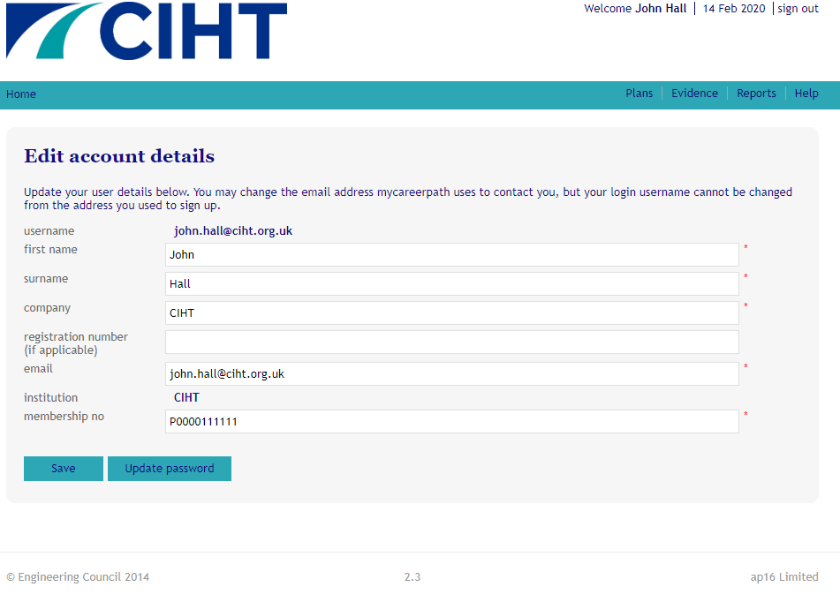

Remember to Save changes when finished.

For More Information

For more information on MyCareerPath or for support to register your own MyCareerPath account, please speak to CIHT’s Professional Development Officer, John Hall at: john.hall@ciht.org.uk

When asked about MyCareerPath, John Hall, CIHT’s Professional Development Officer said:

“Using MyCareerPath is so quick and simple. Members can copy and paste a CPD portfolio directly into the online platform, as well as uploading supporting documents and evidence, such as certificates, photographs, and reports, to name a few. Once uploaded, members can quickly and easily create and download reports of all previous activities, which can be sent directly to line managers or mentors so they can provide productive feedback. CPD is a very important part of any professional’s career, so please set aside some time to create a MyCareerPath account and record your CPD activities.”

