CIHT NI Annual Gala Dinner
Thursday 4 April 2019
Stormont Hotel, Belfast
7pm arrival for Dinner at 7.30pm

CIHT Northern Ireland would like to invite you to their Annual Gala Dinner. As one of the region’s best networking events we are excited to host the event in one of Belfast’s locally owned venues, The Stormont Hotel. We look forward to welcoming you as individuals, small groups or those who wish to host corporate tables. We also warmly welcome partners, friends and colleagues to enjoy the evening’s company and entertainment.

Please note that dress code is formal.

£800 + VAT for a Table (10 guests) / £80 + VAT pp for Individuals/Small Groups
Please use attached Booking Form to book and return payment by 15th March 2019. Due to the popularity and demand of this event, an early response would be appreciated in order to secure your place.

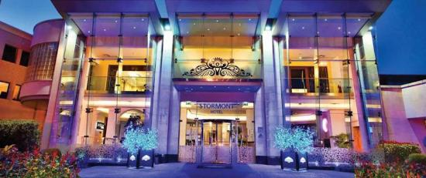

CIHT NI Annual Gala Dinner – Booking Form

All bookings must be notified, and payment made in full, to CIHT NI Dinner Secretary by 15th March 2019.

Booking Form: Corporate Table (10 Guests) @ £800 + VAT per Table
Name of Lead Company / Organisation:
Contact Details:
Telephone: |  |  | Email:
No of tables:
Total payment:
Method of payment¹  (please tick which applies) | cheque |  |  | Online Payment |  |  | Invoice
Dietary Requirements²:

Booking Form: Individuals³ / Small Groups @ £80 + VAT per Person
Name of Lead Contact or
Company / Organisation:
Contact Details:
Telephone: |  |  | Email:
No of people:
Total payment:
Method of payment¹  (please tick which applies) | cheque |  |  | Online Payment |  |  | Invoice
Dietary Requirements²:

¹We accept the following methods of payment:
- By cheque – please make cheques payable to CIHT NI and include with booking form
- By Online Bank Transfer – Account Name CIHT-NI; Sort Code 16-00-16; Account No. 10091330
- If you wish CIHT to issue an invoice, please contact the CIHT NI Treasurer at stephen.bradshaw@infrastructure-ni.gov.uk, ensuring to copy in the Dinner Secretary at the details below.
²Special Dietary Requirements can also be notified following your booking, up to 2 days prior to the event.
³Discretionary discounted rates are available for students and retired CIHT members and their partners. Please contact CIHT Dinner Secretary at the details below for further information.

Please return Booking Forms and payment in full by 15th March 2019 to: CIHT NI Dinner Secretary:
Steven Caldwell, Tennants Bitumen, 9 Airport Road West, Belfast BT3 9ED

Email: stevenc@ctni.co.uk Telephone: 028 9045 5135

